Lab 3 – Power Supply Part 1

CE-3101/021 Digital Elex. and Comp. Interfacing

By:

Andrew Iliescu

4-11-2020

**Abstract:**

The ability to rapidly simulate circuits and make changes on the fly is an invaluable tool that has allowed us to analyze circuits rapidly and effectively. This is because of programs like Waveform and the Analog Discovery Kit which allow us to create circuits on a breadboard and then analyze their behavior on a computer. In this lab we are building a half wave and a full wave rectifier with a filter. This allows us to model the behavior in a power supply which attempts to convert the AC voltage into DC. Using the Analog Discovery kit and the Waveforms program we can see how to diode rectifiers either get rid of the negative voltage or change it to positive, and then the filter comes in to reduce the ripple voltage by decreasing the distance between the peaks and troughs of the voltage.

**Methods:**

Figure 1: Circuit diagram, taken from Ms.Varnell’s CE3101 Lab 3 document

The circuit in figure 1 was built on a breadboard and then analyzed using the waveforms program. First the diode rectifier circuit was built, which can be seen in figure 2. This was a half wave rectifier and it was then analyzed to see the impact it has on the circuit. Next the filter was added in (figure 3) to reduce the ripple voltage, and thus the circuit in figure 1 was built and analyzed using a half wave rectifier. The filter that was used was a 22F capacitor that slowed down the voltage drops to create a more DC voltage from the AC source. Then a full wave rectifier was implemented (figure 4) to see how it impacts the circuit, and subsequently a 100F capacitor filter was added (figure 5), which shows how the circuit in figure 1 performs with a full wave rectifier and filter. The other components used in these circuits include two 1kΩ resistors and 2 1N4148 diodes.

Figure 2: Half wave rectifier circuit with no filter

Figure 3: Half wave rectifier circuit with 22F capacitor filter

Figure 4: Full wave rectifier circuit with no filter

Figure 5: Full wave rectifier circuit with 100F capacitor filter

**Results:**

After conducting the lab, we were able to see the impact on of having diode rectifiers and filters on AC voltage. The half wave rectifier circuit shown in figure 2 was tested in the Waveforms program, which acts as an oscilloscope, and the results are shown in figure 6. It shows how the half wave rectifier cuts out all of the negative values from the sinusoidal AC voltage and sets them to 0.

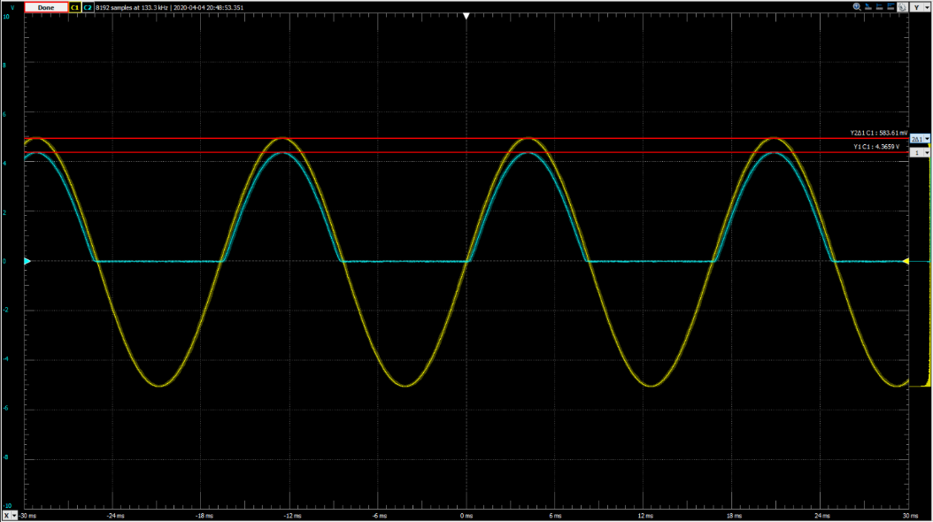

Figure 6: Oscilloscope results from the circuit in figure 2

Next a filter was added in order to decrease the voltage drop between peaks in order to create an output DC voltage from the AC input voltage. This filter was a 22F capacitor and because the capacitor takes time to discharge, it couldn’t discharge completely in between the voltage peaks and this creates a steadier flow of voltage in the circuit making it act more like a constant DC voltage source is being applied. The results are shown in figure 7.

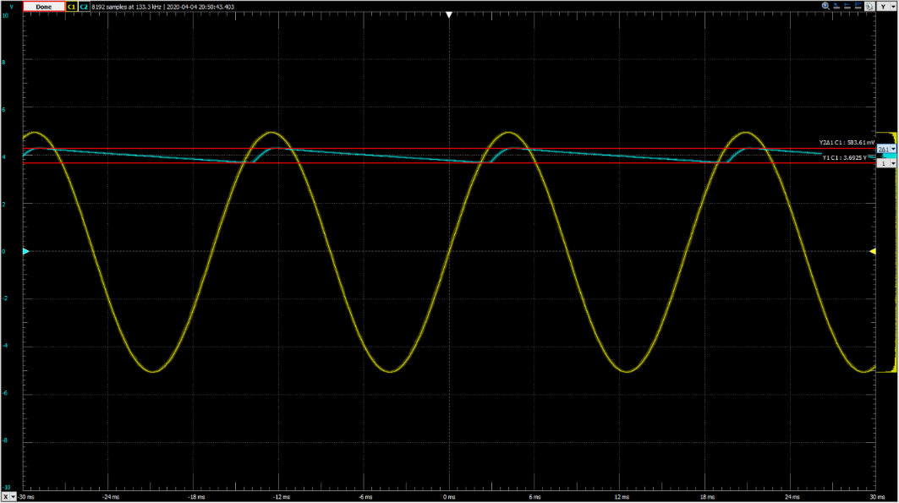

Figure 7: Oscilloscope results from the circuit in figure 3

While the half wave rectifier and filter do create promising results, a lot of the negative voltages are wasted because they become 0. This leads to there still being a change in voltage across the entire circuit even with a filter. This voltage change is known as the ripple voltage. A way to decrease the ripple voltage and thereby get better results would be to use a full wave rectifier. When the full wave rectifier circuit was built and used the results are shown in figure 8. The full wave rectifier converts all of the negative voltage inputs to positive, so unlike the half wave rectifier, the negative voltages aren’t wasted.

Figure 8: Oscilloscope results from the circuit in figure 4

Once again, a capacitor is placed in the circuit to act as a filter in order to reduce the ripple voltage, and this capacitor is 100F. Now that the distance between peaks has been halved the ripple voltage has decreased significantly as shown in figure 9.

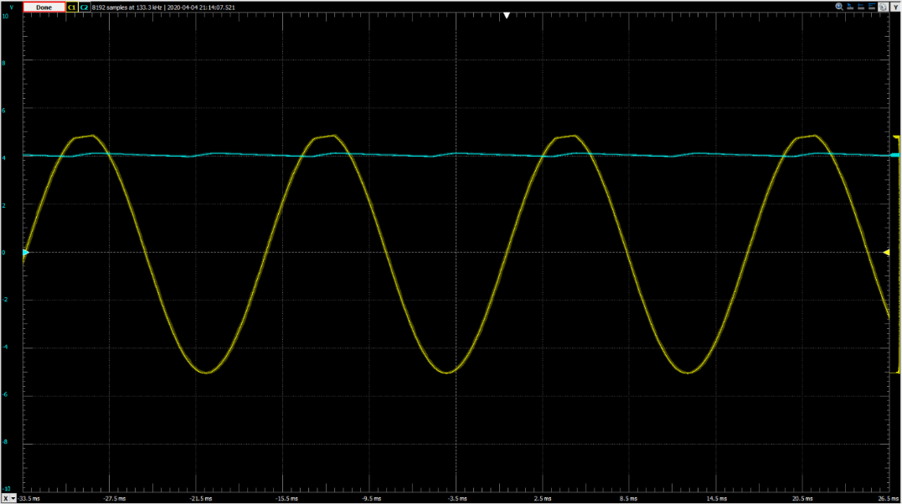

Figure 9: Oscilloscope results from the circuit in figure 5

Now the ripple voltage changes are so minute that the voltage almost looks DC in nature. In order to get a better view of the actual voltage difference a -5V offset is used to enlarge the ripple voltage graph (figure 10).

Figure 10: Oscilloscope results of the circuit in figure 5 with a -5V offset on Channel 2

Now the lab also posed some questions which need to be answered, and these are:

1. **Comment on the differences/similarities between prelab and lab ripple voltage values.**

The largest difference between the prelab calculation for the ripple voltage and the lab calculations was the fact that the lab was done using a 5V source whereas the prelab used a 10V source. However, if we adjust the prelab calculation, we get a value that is roughly 660mV and the result from the experiment is 583.61mV for the half wave rectifier with a filter. That is a difference of 11.6%. For the full wave rectifier and filter the calculated value was 190mV whereas the value from the experiment was 157.13mV. That is a difference of 17.3%. While the values for the ripple voltage between the calculation and the experiment are close, the experimental values keep coming up short.

**Summary:**

After conducting this lab and going through all of the data, the most important takeaways are as follows: a half wave rectifier converts negative AC voltage values to 0, a full wave rectifier converts the negative AC voltages to their positive counterparts, and a capacitor acts as a filter to slow down the change in voltage of a circuit in order to make the AC voltage act like DC voltage.

**Appendix:**

No items to present